**Name**: Faten Abd elkader Eid Abd elkader

**B.N/** 562

**Date**: 6-6-2021

**Topic**: Computer Engineering Role In COVID-19 Pandemic.

**Application Brief**: I am interested in this topic because it is a topic that concerns public opinion and I would like to talk about it

**GitHub-Link:**

<https://github.com/faten2114/Computer-Engineering-Role-In-COVID-19-Pandemi-Faten-Abd-elkader-Eid.git>

**GitHub-Page(Published Website):**

<https://faten2114.github.io/Computer-Engineering-Role-In-COVID-19-Pandemi-Faten-Abd-elkader-Eid/>

**Screenshots**:

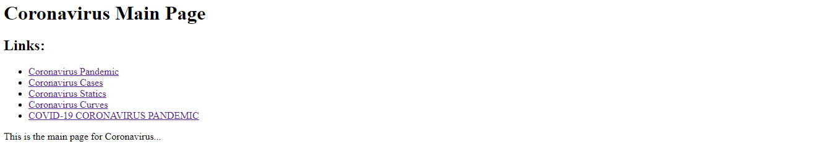

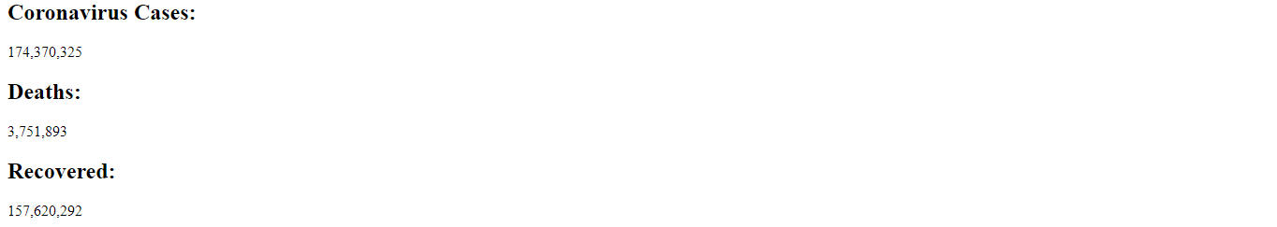

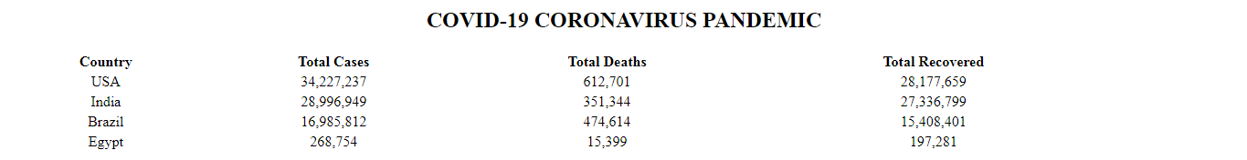

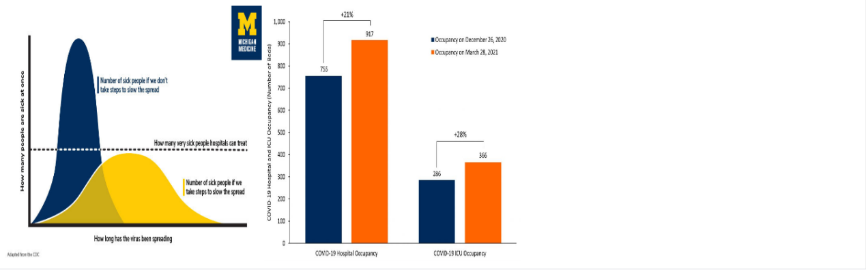

**Source Code**:

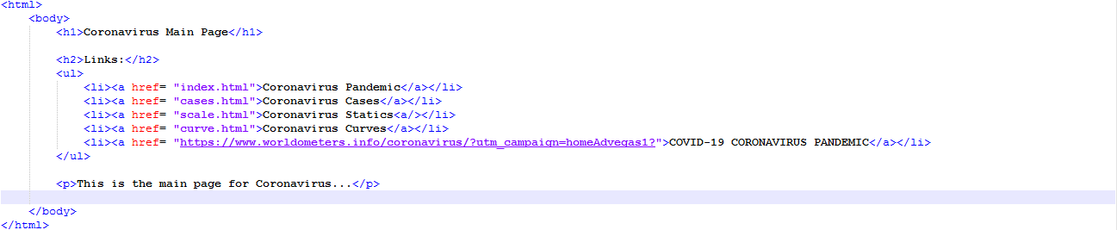

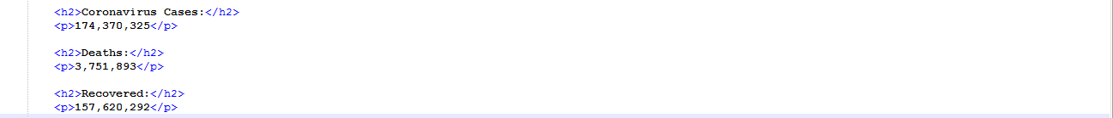

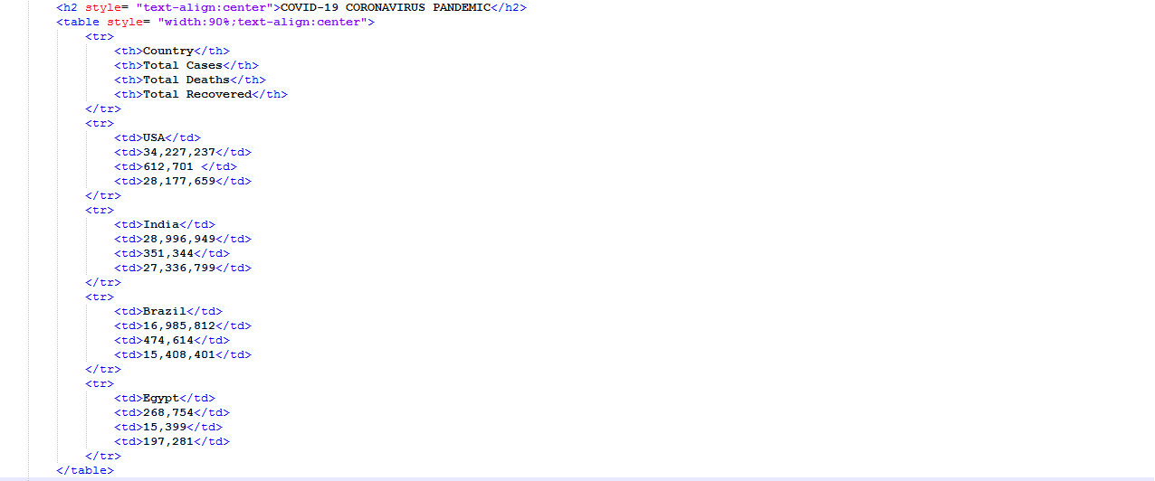

8